COVID-19
Temperature Monitoring

Summary of COVID-19 Temperature Monitoring Process
This document outlines the temperature monitoring process for XYZ Company. Topics include:
- Personal Protective Equipment
- Using the No Touch Temperature monitor
- Criteria for “Pass” “Fail” of Temperature monitoring

Scope:
XYZ COMPANY requires temperature monitoring of all visitors, contractors, temporary labor, and employees daily. This document defines the general processes and safety requirements to conduct this temperature monitoring.

Personal Protective Equipment (PPE):
Personal protective equipment is critical to protect the person(s) conducting the temperature monitoring from potential exposure. This section describes the mandatory minimum PPE required by those conducting the temperature monitoring.
Training: All person(s) that will be conducting the temperature monitoring must be trained on the following:
- The minimum PPE required to conduct this task
- How to properly “Don” (Put on/fit) & “Doff” (take off and clean/dispose) the required PPE
The chart below describes the required PPE for the person(s) conducting the temperature monitoring.
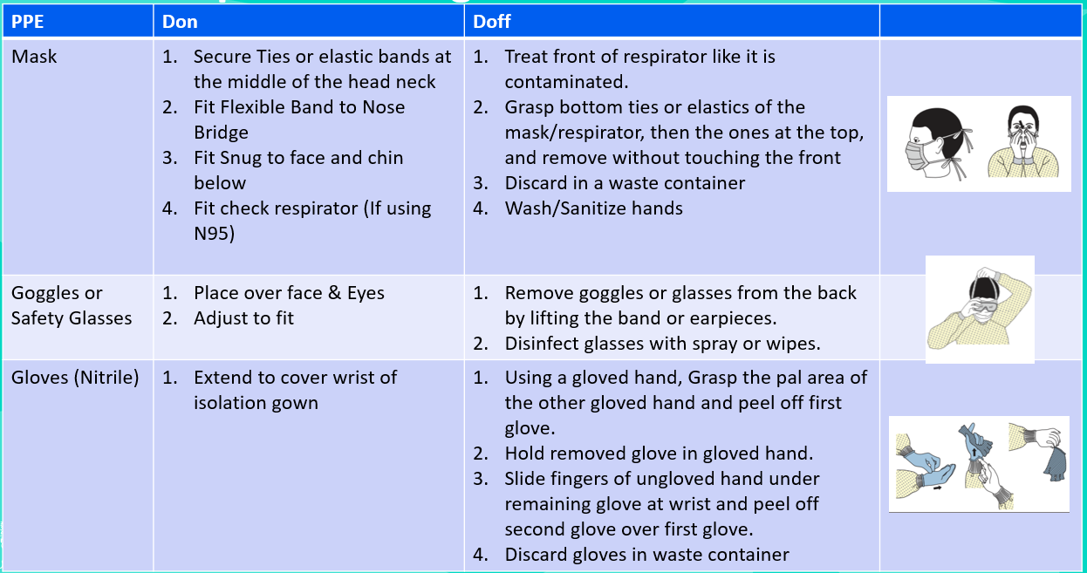
Donning: When donning the required PPE, the following order must be followed. Each item must be donned per the chart above.
- Wash hands or use an alcohol-based hand sanitizer.
- Don the mask (ONE TIME USE ONE PER SHIFT)
- Don the safety goggles or glasses
- Don the gloves.
Doffing: When doffing the required PPE, the following order must be followed. Each item must be Duffed per the above chart. Always treat PPE items as if they are contaminated practice with caution. Perform hand hygiene between steps if hands become contaminated.
- Duff the gloves & dispose
- Duff the goggles (wipe down with alcohol disinfecting wipes or like cleaner)
- Duff the mask & dispose
- Wash hands and use an alcohol-based hand sanitizer immediately after removing all PPE.
Defective, Worn PPE: If at any point PPE becomes worn or is made defective, the person(s) completing temperature monitoring must doff using the doff process, wash hands/sanitize and request replacements.

Conducting Temperature Monitoring using No Touch Thermometer

Temperature Monitoring Precautions/ Social Distancing: It is important to note that while screening all sites must enforce social distancing. Limiting the number of people in an area and maintaining separation is key in limiting the spread of any virus. Sites should evaluate how they conduct Temperature monitoring and take measures to limit risk.

Using the Thermometer:
- Follow manufacturer’s directions exactly

Pass Fail Criteria and action:
- If reading is 100.4F or above recheck in 15 mins. If the second test is over 100.4F, a fever is present, and employee is to be sent home. XYZ will rely on its current vacation and sick-leave policy which can be found in the employee handbook located in the document section of the employee profile in Paycor.
  - Person(s) waiting to be retested must be asked to wait in an area that meets the social distancing requirements.
Indicate “Pass” or “Fail” on the Screening Questionnaire. If fail contact HR DEPT.

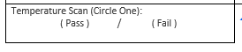

OSHA Voluntary use of Respirator Requirement Appendix D: OSHA requires all employees who use respirators voluntarily to be provided with a copy of Mandatory Information for Employees Using Respirators When Not Required Under the Standard, found at 29 CFR Subpart I, Appendix D. This must be provided for any employee using a N95 Respirator. This is not required for the use of surgical masks.
In addition, for all person(s) using an N95 respirator, they must also be provided with the MFG guidelines on usage. This is attached at the end of the document.

Appendix D to Sec. 1910.134 (Mandatory) Information for Employees Using Respirators When Not Required Under the Standard
Respirators are an effective method of protection against designated hazards when properly selected and worn. Respirator use is encouraged, even when exposures are below the exposure limit, to provide an additional level of comfort and protection for workers. However, if a respirator is used improperly or not kept clean, the respirator itself can become a hazard to the worker. Sometimes, workers may wear respirators to avoid exposures to hazards, even if the amount of hazardous substance does not exceed the limits set by OSHA standards. If your employer provides respirators for your voluntary use, or if you provide your own respirator, you need to take certain precautions to be sure that the respirator itself does not present a hazard.
You should do the following:
1. Read and heed all instructions provided by the manufacturer on use, maintenance, cleaning and care, and warnings regarding the respirator’s limitations.
2. Choose respirators certified for use to protect against the contaminant of concern. NIOSH, the National Institute for Occupational Safety and Health of the U.S. Department of Health and Human Services, certifies respirators. A label or statement of certification should appear on the respirator or respirator packaging. It will tell you what the respirator is designed for and how much it will protect you.
3. Do not wear your respirator into atmospheres containing contaminants for which your respirator is not designed to protect against. For example, a respirator designed to filter dust particles will not protect you against gases, vapours, or very small solid particles of fumes or smoke.
4. Keep track of your respirator so that you do not mistakenly use someone else's respirator.

N95 Respirator User Guidelines:

